

Practices for Secure Software Report

Table of Contents
Document Revision History 3
Client 3
Instructions 3
Developer 4
1. Algorithm Cipher 4
2. Certificate Generation 4
3. Deploy Cipher 4
4. Secure Communications 4
5. Secondary Testing 4
6. Functional Testing 4
7. Summary 4
8. Industry Standard Best Practices 4

Document Revision History

Version | Date | Author | Comments
1.0 | 4/17/2026 | Alex Wilson | Implemented a hash function, server controller, and HTTPS

Client



Developer
Alex Wilson

Algorithm Cipher

For the Artemis Financial application, the recommended encryption algorithm is Advanced Encryption Standard (AES-256). AES is a symmetric block cipher and is widely used to protect sensitive financial data (Oracle, 2017). It operates on 128-bit blocks and supports key sizes of 128, 192, and 256 bits, with AES-256 providing the highest level of security (Oracle, 2017). It is also efficient, broadly supported, and approved for government and enterprise use, which makes it appropriate for protecting Artemis Financial’s financial services and client data.

In this project, SHA-256 was implemented in the controller to generate a checksum for returned data. To further expand on this implementation, SHA-256 produces a 256-bit hash value that functions as a checksum, which serves as a mechanism for the system to detect whether any data has been tampered with (Oracle, 2017). This meets Artemis Financial’s requirement to verify file integrity.

AES is a symmetric encryption method, meaning the same key is used for both encryption and decryption. Because of this, secure key management is especially important. Encryption keys should be generated using secure random number generators, and initialization vectors are used to ensure unpredictability. In secure system architectures, asymmetric encryption algorithms such as RSA are often used to securely exchange symmetric AES keys between systems before communication occurs (Manico & Detlefsen, 2014).

AES replaced the Data Encryption Standard (DES), which became obsolete due to its limited 56-bit key size and vulnerability to brute-force attacks. The National Institute of Standards and Technology adopted AES after evaluating stronger encryption candidates capable of resisting modern cryptographic attacks. In practice, AES-256 combined with SHA-256 is commonly used to protect sensitive data both in transit and at rest in financial applications (Chen & Scholl, 2022).

Certificate Generation

Below is a screenshot of the self-signed certificate, which was generated using keytool:

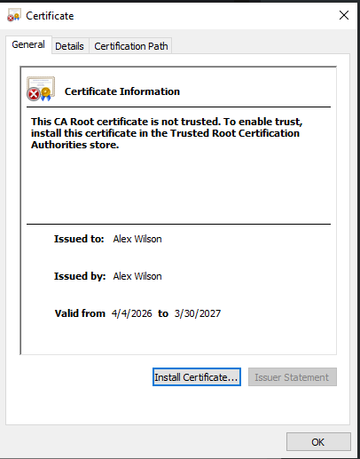

Deploy Cipher
Below is a screenshot of the checksum verification:

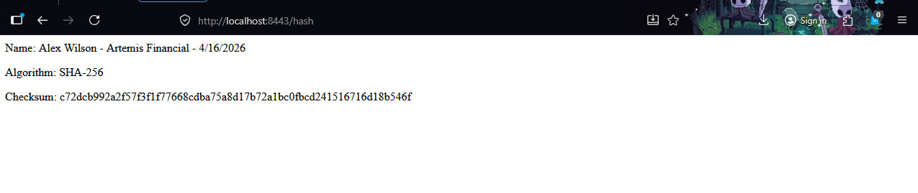

Secure Communications
Below is a screenshot of the hash endpoint accessed via a secure HTTPS connection:

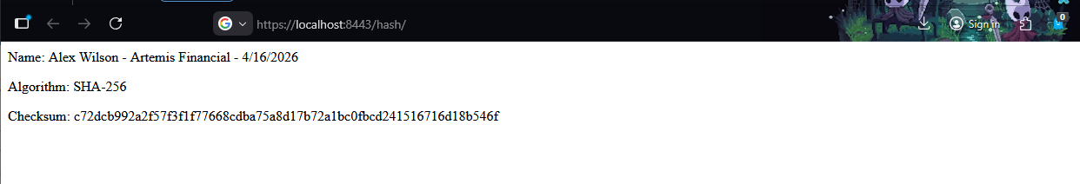

Secondary Testing
Below is a screenshot of the refactored application.properties, along with the console showing no errors upon execution:

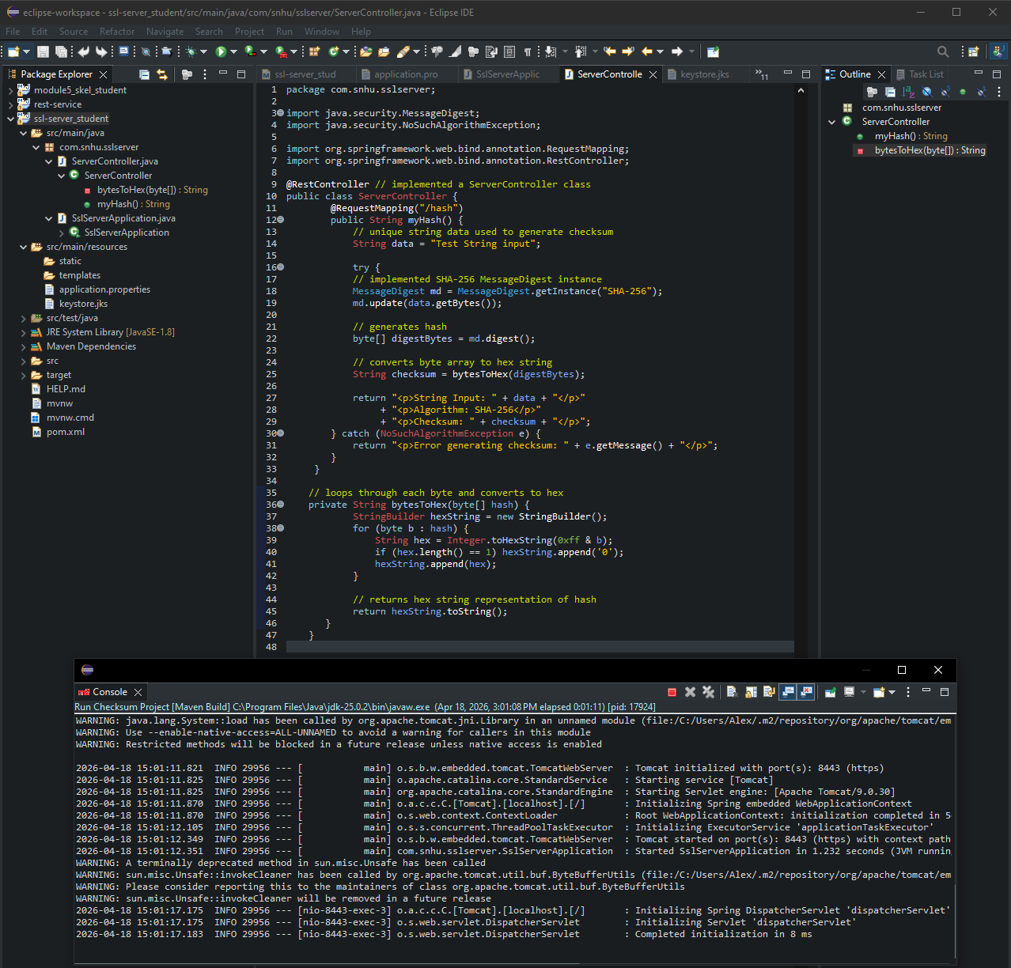

Below is a screenshot of the dependency check report. The scan reported several vulnerabilities, however the refactored code did not add any new third party libraries and therefore did not introduce new vulnerabilities:
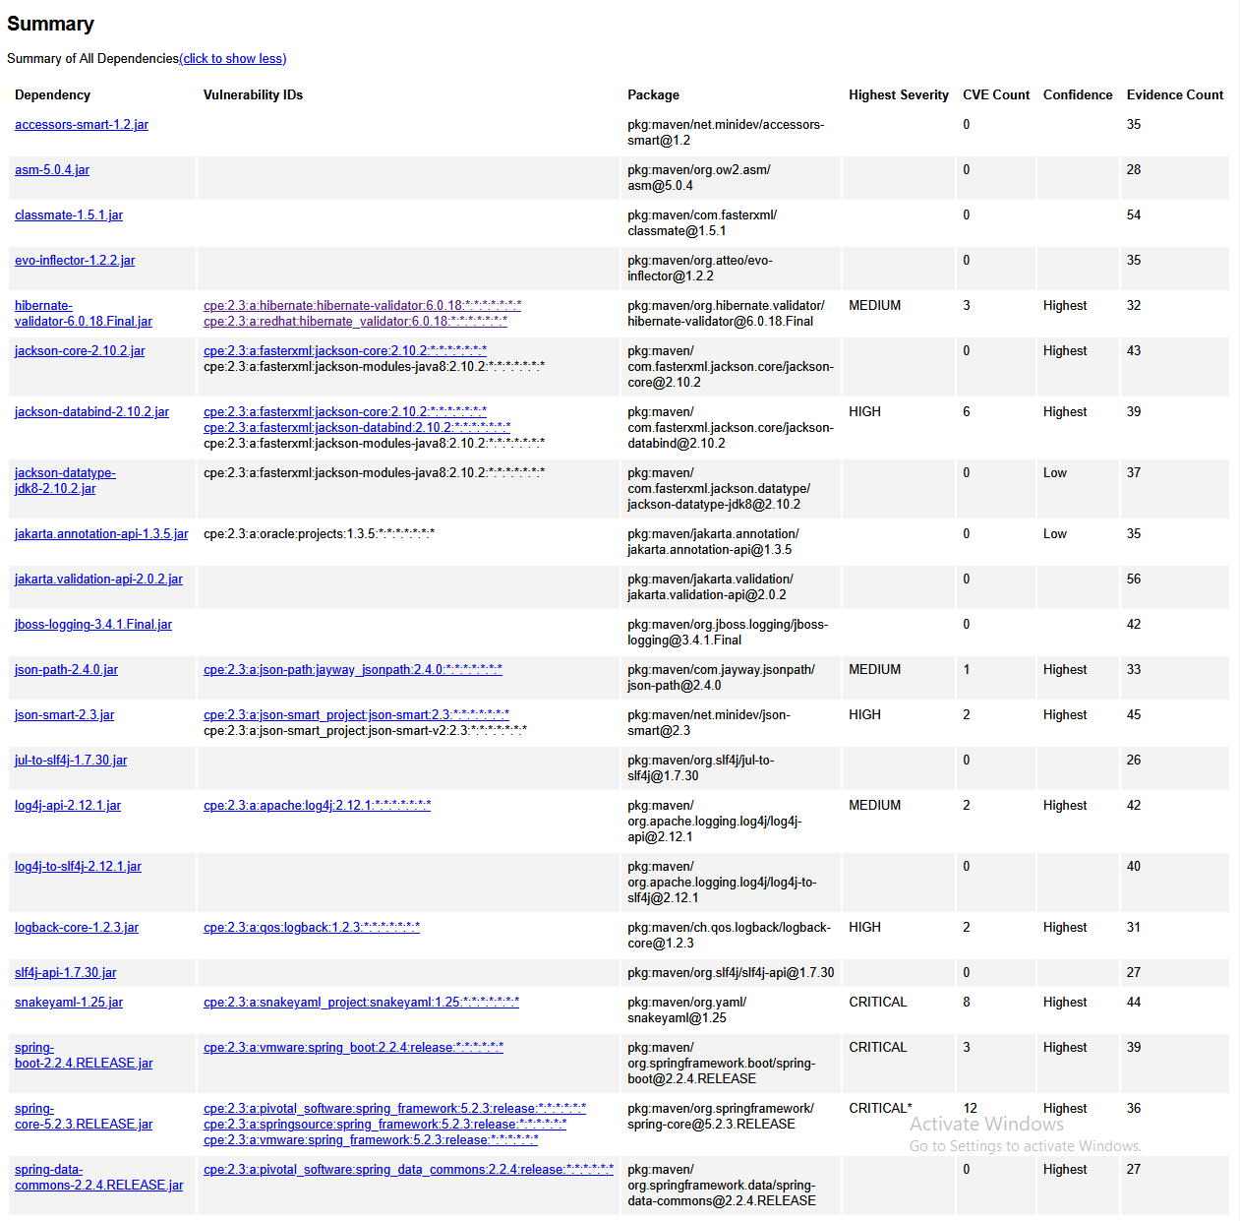

Functional Testing
Below is a screenshot of the refactored code, which includes a new data string input. Upon accessing the /hash endpoint, the string input is shown. Also included is the console confirming error free code execution:

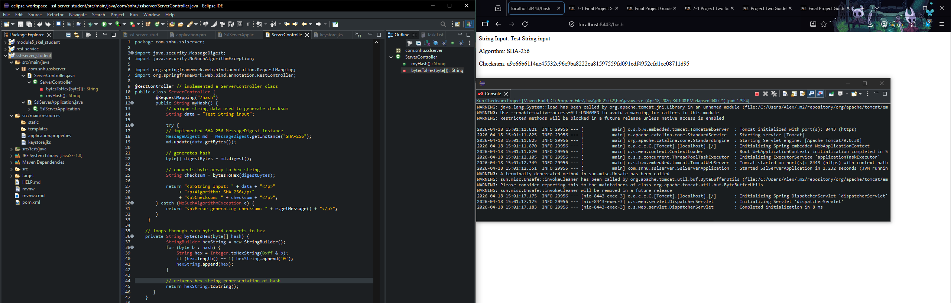

Summary

The application was refactored to improve security and follows the vulnerability assessment process. Based on the process flow diagram, the main areas addressed were Cryptography, Client/Server, and Code Quality.

HTTPS was configured using a self-signed SSL certificate to encrypt client-server interactions. A checksum verification was also implemented, using SHA-256 hashing to validate file integrity. In the current implementation, the checksum is generated using a fixed sample string, so the result is easy to verify during testing.

Secondary testing was done using the dependency check tool to verify no vulnerabilities were introduced when refactoring the code. The scan identified several vulnerabilities already present in the code base, however the refactored code was implemented using java.security and HTTPS was configured through application properties and the generated keystore. Therefore, the secondary testing shows the refactored code didn’t create any additional vulnerabilities. Functional testing was done by executing the refactored code base, manually reviewing the refactored code, and verifying correct behavior of the /hash endpoint. Upon code execution, the console showed there were no syntax or runtime errors. Manual review of the ServerController showed that java.security.MessageDigest was implemented correctly using the SHA-256 algorithm, and the bytesToHex method was found to correctly convert hash bytes to a hexadecimal string. The review also revealed some hardcoded configuration values, with the keystore password being visible in application.properties. This is fine for a development environment but should be changed prior to deployment, either by making use of environment variables or using a secure configuration service. The endpoint was tested using multiple new input strings to verify the SHA-256 hashing was working as intended. The results of the functional testing showed that different inputs yielded different checksum values whereas identical inputs yielded identical checksum values.

Industry Standard Best Practices

In review, Artemis Financial’s security requirements were addressed using industry standard secure coding practices. The requirement for secure file integrity verification was implemented through a SHA-256 checksum exposed via the /hash endpoint, meaning transmitted data can now be validated against tampering. Secure communications requirements were met by configuring HTTPS with a self-signed SSL certificate for development and testing. That said, prior to deployment, a CA-signed certificate would be required to meet industry trust standards regarding customer-facing web interfaces. Data confidentiality requirements were met through TLS encryption, which protects client-server communication from interception and modification.

In addition, dependency-check static analysis was used specifically to verify that the refactored code did not introduce new known vulnerabilities through added dependencies or configuration changes. This was complemented by manual functional testing to confirm the application executes without syntactical, logical, or security-related errors.

Using secure coding practices improves a company’s overall security by reducing vulnerabilities and protecting sensitive information. As a financial consulting company handling sensitive client data including savings, retirement, investments, and insurance information, a security failure would likely result in significant financial losses, regulatory penalties, and erosion of customer trust that would be difficult to recover from. By implementing proven security measures such as SHA-256 integrity verification and dependency vulnerability scanning, the application is built on a strong foundation of security standards. This is especially important in the financial sector, where regulations like the Gramm-Leach-Bliley Act require firms to protect client financial information (Federal Trade Commission, 2026). Furthermore, secure coding practices reduce the long-term cost of post-deployment maintenance, as vulnerabilities are caught early.

References
Chen, L., & Scholl, M. (2022). The cornerstone of cybersecurity: Cryptographic standards and a 50-year evolution. National Cybersecurity Center of Excellence.
https://www.nccoe.nist.gov/news-insights/cornerstone-cybersecurity-cryptographic-standards-and-50-year-evolution

Manico, J., & Detlefsen, A. (2014, September 12). Iron-clad Java. O’Reilly Online Learning. https://learning.oreilly.com/library/view/iron-clad-java/9780071835886/ch06.html

Oracle. (2017). Java security standard algorithm names. https://docs.oracle.com/javase/9/docs/specs/security/standard-names.html

Federal Trade Commission. (2026). Gramm-Leach-Bliley Act. https://www.ftc.gov/business-guidance/privacy-security/gramm-leach-bliley-act

